Tokyo Challenge Miles/ Steps Log

Welcome to the Tokyo Challenge.
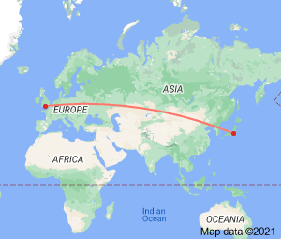

- Taking part is optional
- You can take part by walking, running, swimming, rowing etc as long as it’s something active.
- Keep track of your daily steps or miles in the log below. You can track miles / steps using most smart phones or a free app.
- Send them to us weekly on the highlighted days, or all in one go at the end of the challenge on the 5th September.
- You can take part just for fun or if you’d like to ask for sponsorship, you can use our team Just Giving page:
https://www.justgiving.com/fundraising/ycttokyo

Name:

Date | Miles or Steps | Tally | Activity  (Running, walking, swimming, rowing etc )
23rd July
24th July
25th July
26th July
27th July
28th July
29th July
30th July
31st July
1st August
2nd August
3rd August
4th August
5th August
6th August
7th August
8th August
9th August
10th August
11th August
12th August
13th August
14th August
15th August
16th August
17th August
18th August
19th August
20th August
21st August
22nd August
23rd August
24th August
25th August
26th August
27th August
28th August
29th August
30th August
31st August
1st September
2nd September
3rd September
4th September
TOTAL:

Well done for Completing the Tokyo Challenge
Don’t forget to send your miles log to wendy@yct.org.uk

